**How Data Scientists Level Up Their Coding Skills**

There are many paths into a data science career, and not all of them involve a strong programming background. When we hear data practitioners second-guess themselves and their abilities, a recurring theme is code: “Am I even a *real* data scientist if I don’t know how to [*insert your own perceived coding shortcoming*]?”

Well, yes, you are! Nobody knows everything; all we can hope for is to recognize the gaps in our knowledge and to find an effective way to tackle them. This week’s highlights are here to help you in your coding journey: each of them approaches the (vast) topic of programming for data science from a different angle, and each offers different types of actionable takeaways. Enjoy!

* [**What is good code, anyway?**](https://towardsdatascience.com/good-data-scientists-write-good-code-28352a826d1f)

[Sergey Mastitsky](https://medium.com/u/eb6eb1386f4f?source=post_page-----edf15bbde334--------------------------------)

’s excellent introduction to coding best practices is thorough, accessible, and detailed. It’s also a useful reminder that writing clean, clear code isn’t about showing off your technical prowess, but rather about generosity and empathy towards your colleagues and users.

* [**Master the essentials of logging**](https://towardsdatascience.com/basic-to-advanced-logging-with-python-in-10-minutes-631501339650). Another crucial aspect of being a dependable teammate? Ensuring there are good logging calls within your code so that it’s easy to debug.

[Kay Jan Wong](https://medium.com/u/fee8693930fb?source=post_page-----edf15bbde334--------------------------------)

’s primer on logging goes from basic functions all the way to more advanced and specialized ones, covers common issues, and includes a full implementation in Python.

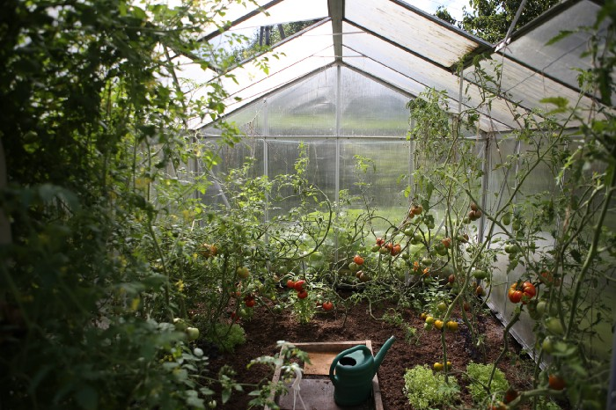

Photo by [www.zanda. photography](https://unsplash.com/@zanda_photography?utm_source=medium&utm_medium=referral) on [Unsplash](https://unsplash.com?utm_source=medium&utm_medium=referral)

* [**How your Python skills can streamline your workflows**](https://towardsdatascience.com/3-tools-for-fast-data-profiling-5bd4e962e482). Staying on the practical side of things,

[Rebecca Vickery](https://medium.com/u/8b7aca3e5b1c?source=post_page-----edf15bbde334--------------------------------)

walks us through the ins and outs of three Python libraries—Lux, Pandas Profiling, and SweetViz—that automate the routine task of profiling data (an important first step in any data-science analysis before you apply other techniques).

* [**It’s never too late to change course**](https://towardsdatascience.com/how-i-would-learn-to-code-if-i-had-to-start-over-607428f14266).

[Ken Jee](https://medium.com/u/6ee1f7466557?source=post_page-----edf15bbde334--------------------------------)

recently shared helpful advice about learning to code, centered around the different decisions he would’ve made with the benefit of hindsight. One powerful lesson from his article is that no matter where you are in your data science journey, you have time to adapt the way you develop and grow your skills.

We hope you have some time left this week for a few more of the excellent posts we published — it would be a shame to miss out on these!

* After a long and illustrious run as the host of the TDS Podcast,

[Jeremie Harris](https://medium.com/u/59564831d1eb?source=post_page-----edf15bbde334--------------------------------)

shared [one final episode about the future of AI](https://towardsdatascience.com/towards-data-science-podcast-finale-the-future-of-ai-and-the-risks-that-come-with-it-db4d29e77174).

* Choosing the right type of visual for your data science project is crucial.

[Semi Koen](https://medium.com/u/aabf98f9b9a?source=post_page-----edf15bbde334--------------------------------)

’s guide will [help you make solid, effective decisions](https://towardsdatascience.com/how-to-choose-an-effective-visual-for-your-data-science-project-3e7c0a291a55).

* What does an AI opera sound like?

[Nico Westerbeck](https://medium.com/u/6eb9fa1f672?source=post_page-----edf15bbde334--------------------------------)

’s debut post [walks us through the fascinating process](https://towardsdatascience.com/lessons-learned-from-making-an-ai-opera-6b188c3094cf) of creating *Chasing Waterfalls* at the Semperoper in Dresden, Germany.

* Learn how to use TensorFlow’s functional API to [predict two outputs with one model](https://towardsdatascience.com/a-step-by-step-tutorial-to-develop-a-multi-output-model-in-tensorflow-ec9f13e5979c) by following

[Rashida Nasrin Sucky](https://medium.com/u/8a36b941a136?source=post_page-----edf15bbde334--------------------------------)

’s step-by-step tutorial.

* It’s always a privilege to publish new and exciting work by

[Michael Bronstein](https://medium.com/u/7b1129ddd572?source=post_page-----edf15bbde334--------------------------------)

; his latest article (with coauthors Francesco Di Giovanni, James Rowbottom, Ben Chamberlain, and Thomas Markovich) [introduces Gradient Flow Framework (GRAFF), a physics-inspired approach](https://towardsdatascience.com/graph-neural-networks-as-gradient-flows-4dae41fb2e8a) to graph neural networks.

Thank you, as always, for the time you spend with our authors’ work. If you’d like to show your support in other meaningful ways, consider [becoming a Medium member](https://bit.ly/tds-membership).

Until the next Variable,

TDS Editors